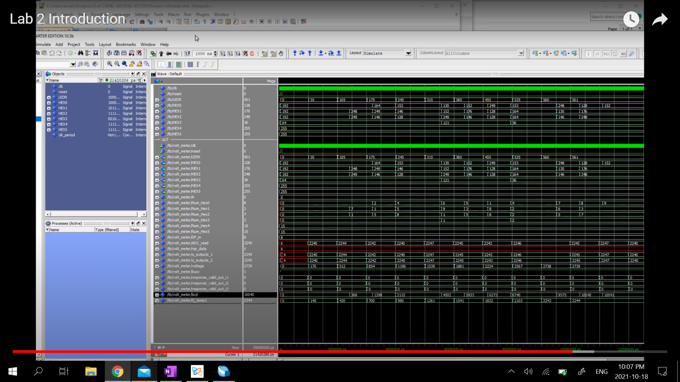For comparison, here is a screenshot of the prelab waveform taken from Dr. Onen’s demonstration…

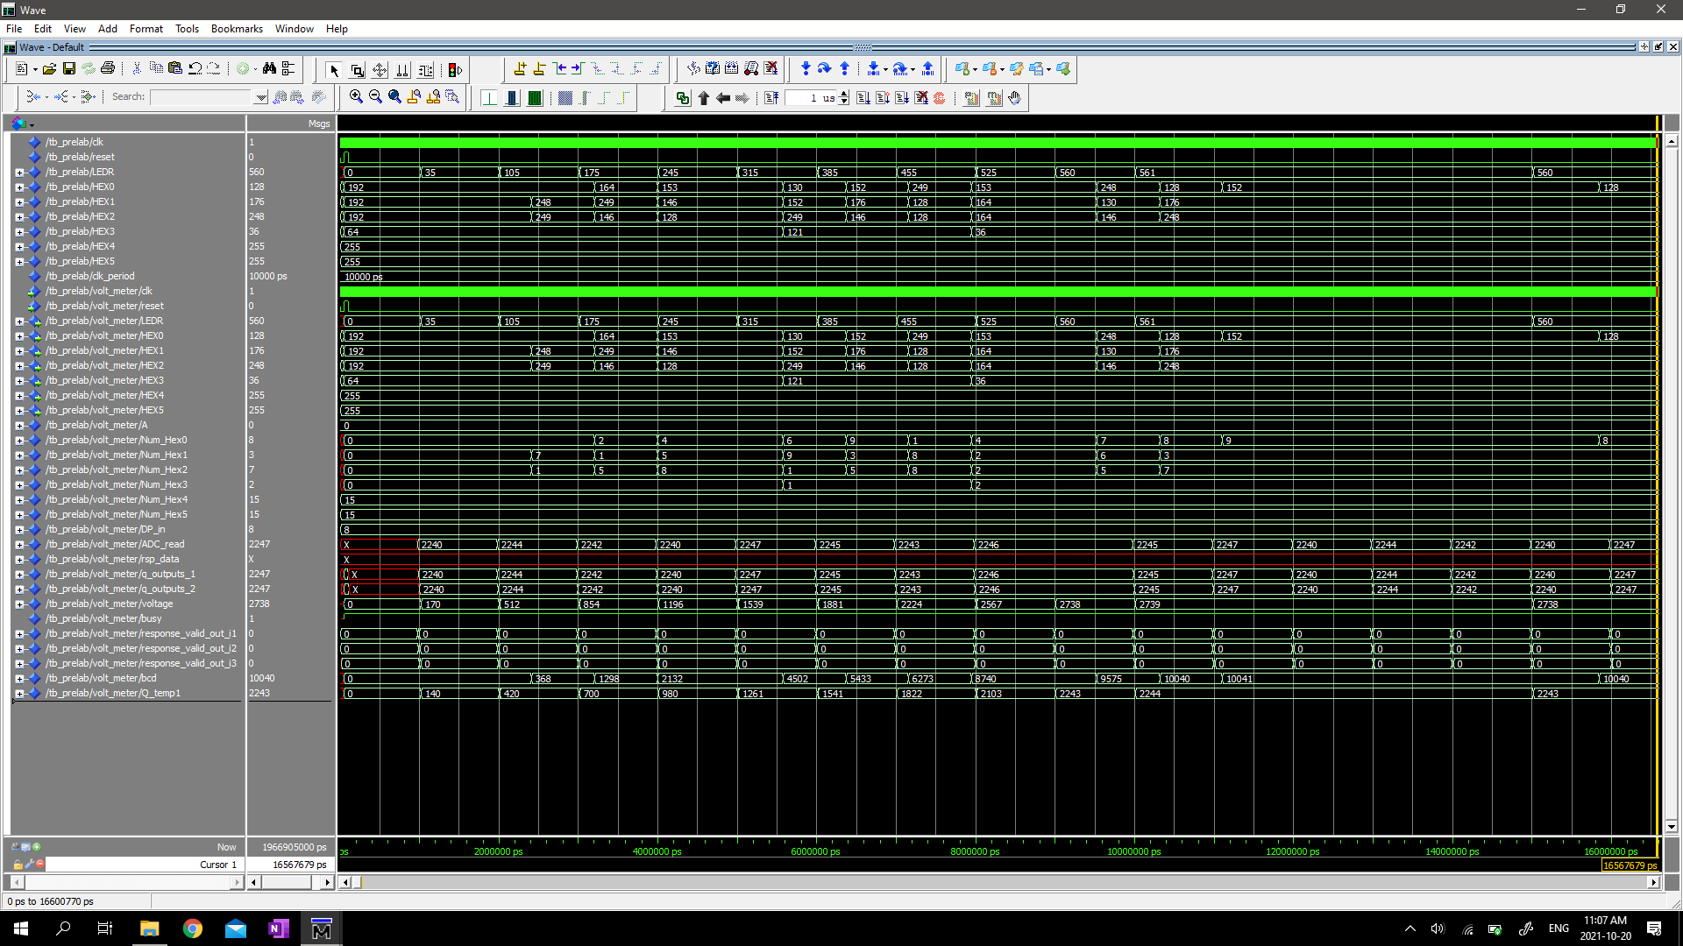And here is our waveform for a similar timeframe. The waveforms are identical.

Here’s a more zoomed-in version…

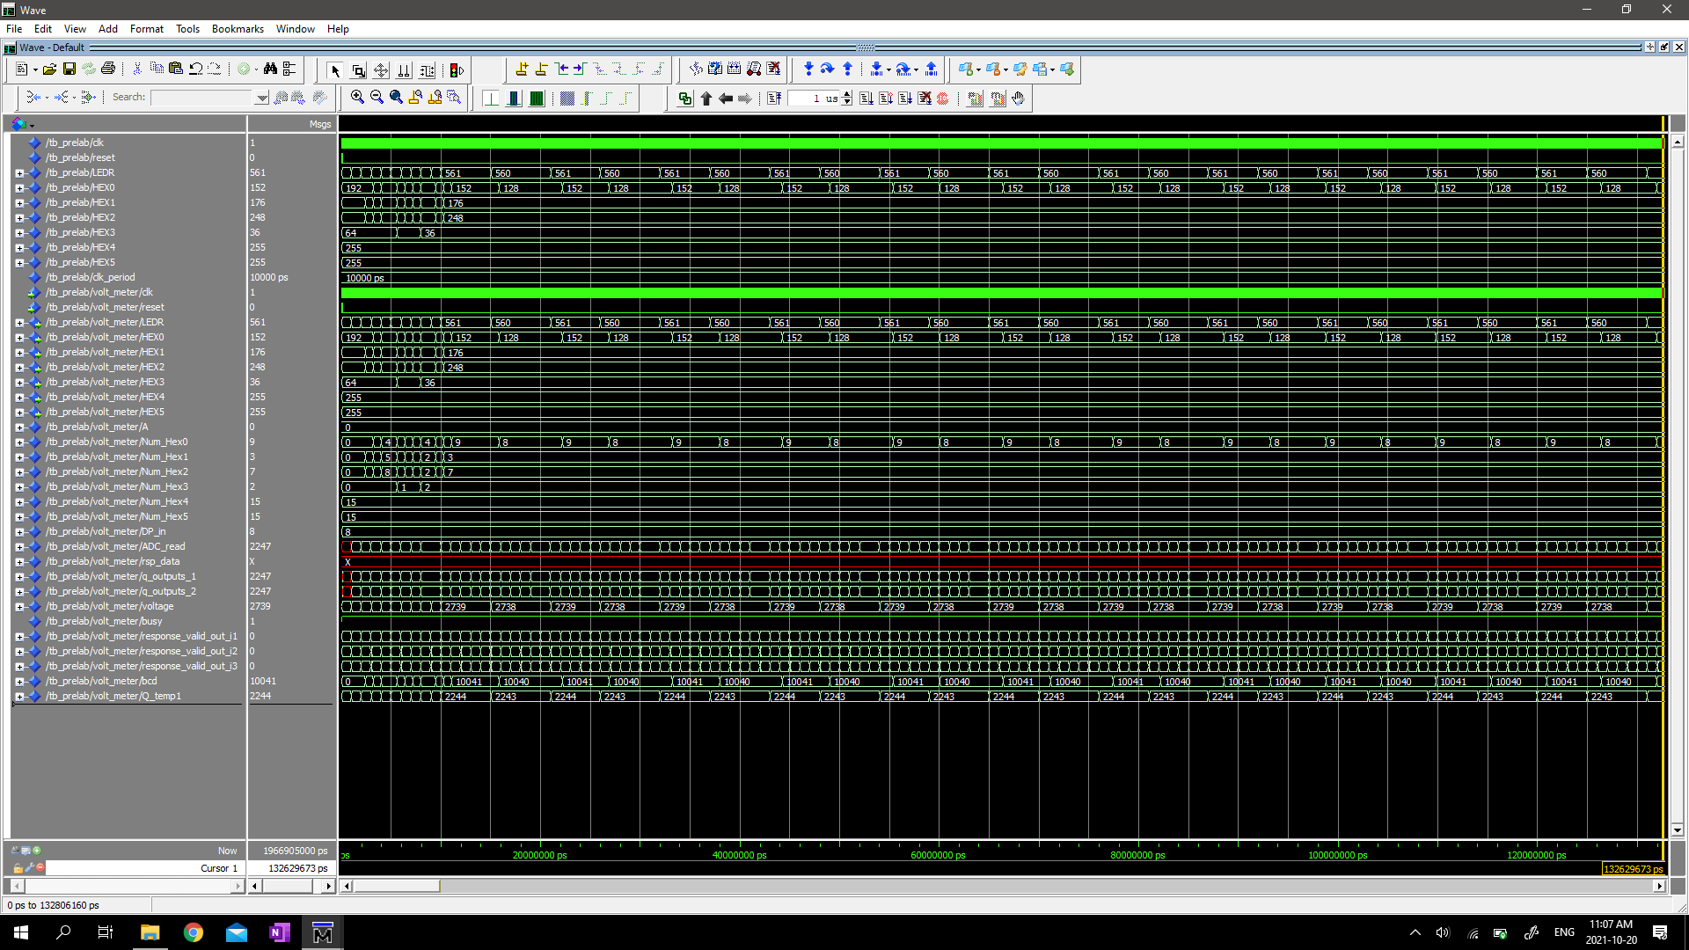And under a different time frame…

Next, we modified the testbench to trigger reset every 5 μs. Here are a couple screenshots of this modified design…

